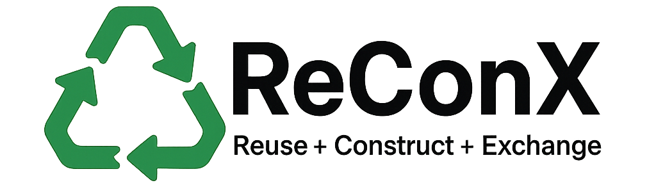
Terms of Service
Effective Date: July 28, 2025
Welcome to the ReConX ("Platform", "we", "us", or "our"). By creating an account, accessing, or using the Platform, you ("User", "you") agree to comply with and be bound by the following Terms of Service. Please read them carefully.

1. Eligibility
You must be at least 18 years old to use the Platform. By using this service, you confirm that you are legally eligible to enter into this agreement.

2. Account Registration
To access key features, users must register for an account as a Donor, Receiver, or Administrator. You are responsible for maintaining the confidentiality of your login information and for all activities that occur under your account.

3. User Roles and Responsibilities
- Donors may list construction materials for reuse or recycling.
- Receivers may browse and request materials for collection.
- Admins oversee platform activity and user compliance.
Users must:
- Provide accurate information
- Refrain from listing hazardous or illegal materials
- Follow local laws for transportation and disposal of construction waste

4. Prohibited Conduct
You agree not to:
- Misuse the platform to distribute harmful, illegal, or misleading content
- Attempt to bypass platform security
- Post fraudulent or duplicate listings
- Harass or impersonate other users

5. Material Listings
All material listings are provided “as-is.” We do not guarantee quality, availability, or accuracy. It is the responsibility of the Donor and Receiver to coordinate pickup, inspection, and delivery.

6. Environmental Impact Metrics
The Platform may display approximate carbon savings and waste diverted statistics. These are for informational purposes only and are not audited or guaranteed.

7. Termination
We reserve the right to suspend or delete your account at any time for violating these terms, without notice or liability.

8. Intellectual Property
The Platform, logo, and all content (excluding user-generated content) are owned by the platform creators and protected by intellectual property laws.

9. Limitation of Liability
We are not liable for any damages resulting from:
- Use or inability to use the platform
- Transactions between Donors and Receivers
- Loss or misuse of data
Use this service at your own risk.

10. Privacy
Your data will be handled in accordance with our Privacy Policy. We do not sell or rent your personal information.

11. Modifications
We may update these Terms periodically. Continued use of the Platform constitutes your acceptance of any changes.

12. Contact
For questions about these Terms, contact us at:
📧 pathuhere10@gmail.com

